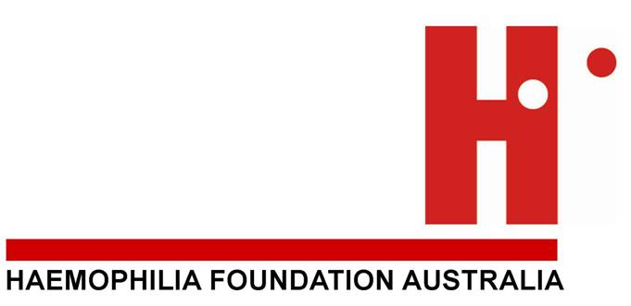

About the Go For It Grants
The Go For It Grants are to inspire and support people affected by a bleeding disorder to achieve new personal goals.
People affected by haemophilia, von Willebrand disorder and other rare inherited bleeding disorders of all ages, anywhere in Australia are eligible to apply.
Go For It Grants have been established by Haemophilia Foundation Australia (HFA) for the community with sponsorship from Pfizer Australia.

Go For It Grants
What would make a difference in your life?
Two grants of $5,000 are available.

Application Timeframes and Deadline
The 2017 funding round is now open. Applications must be received by no later than 5pm 17 February 2017.
Winners will be notified directly and announced in National Haemophilia and on the HFA website www.haemophilia.org.au.

How to Apply
Download the application form from the HFA website www.haemophilia.org.au or www.factoredin.org.au or request a copy from HFA. Lodge your application to HFA by email, post or fax:

7 Dene Ave, MALVERN East VIC 3145
Phone: 03 9885 7800 / Fax: 03 9885 1800 / Email: hfaust@haemophilia.org.au
GUIDELINES AND ASSESSMENT PROCESS

- Go For It Grants Program
The Haemophilia Foundation Australia (HFA) Go For It Grants are available to people with bleeding disorders around Australia. They have been developed and are administered by HFA with sponsorship to HFA from Pfizer Australia.
- Your Privacy
The grant is fully administered by HFA and only HFA will hold personal details supplied by applicants on their application form and any attachments provided. The application will only be available to the judging panel and HFA staff and will be held securely at the HFA office.
HFA will take steps to protect the privacy of applicants, however successful applicants will be asked to agree to details of their grant being published in HFA newsletters and other relevant materials to promote future grants.
Pfizer Australia will not be involved in the administration or judging of the grants and will not have access to any personal details of applicants or winners, other than details that are in the public domain.
- Application process and eligibility criteria – please read carefully. If you do not provide sufficient details your application may be excluded from consideration.
- Applicants must have a bleeding disorder or be affected by a bleeding disorder in a direct way.
- You must use the form provided.
- Every question on the form should be answered carefully so that the judges understand why you want the grant, what it will be used for and how the grant will benefit you or others.
- Your application must include an accurate budget outlining the cost of the project or activity to the value of $5000. Projects costing more or less may not be considered.
- Projects must be capable of completion within one year of the grant being made.
- Grants will not be given for regular school or university fees.
- You must supply two (2) written references with your application in support of your application, including one from a health professional at a Haemophilia Treatment Centre who knows you to confirm that you have a bleeding disorder or that you are affected by a bleeding disorder. The second reference must also be from an independent person, and should not be a family member.
- Applications will be considered on their merit and the expected benefit for the individual who has made the application.
- Applicants must be received by no later than 5pm on 17 February 2017.
- Applicants will be advised as soon as possible of the outcome of their application by mail or email.
- Decisions will be final and no further correspondence will be entered into by either HFA or Pfizer Australia with unsuccessful applicants.
- Grant recipients will be announced in National Haemophilia and on the HFA website subject to agreement to item 2) above.
- Grant recipients will be required to provide a report after completion of the activity and this report may be published by HFA with the agreement of the recipient.
HFA will establish a panel with expertise and interest in education, learning and development and/or personal development to assess applications.
HFA will determine the number of grants to be made each year, on the basis of funds available, and will determine how the funds will be allocated. If there are insufficient applications of merit in any year, HFA reserves the right not to allocate all funds available and the remaining funds will be carried over to the next year.
- Judging Process
- HFA will determine the number of grants to be made each year, depending on the funds and resources available.
- HFA will establish a panel with expertise and interest in education, learning and development and/or personal development to consider applications and make recommendations for grants.
- If there are insufficient applications of merit in any year, HFA reserves the right not to allocate all funds available and the remaining funds may be carried over to the next year.

APPLICATION FORM

Name:
Address: Postcode:
Telephone: Email:
Date of Birth:

BLEEDING DISORDER STATUS (you are not required to provide detailed personal health information, however you must satisfy one of the categories below)

Haemophilia Other Bleeding Disorder Carer
von Willebrand Disorder Carrier Sibling
Other:

1. Describe your goal or the project you wish to undertake

2. How will you and/or others benefit from a GO FOR IT GRANT
3. a) Provide a full breakdown of costs for your project

Item | $
Total cost of project/plan

3. b) If the Grant will not cover the full costs, how will you fund the remainder?

4. Timeframes for your project/proposal: Start Date: End Date:

5. Have you requested funds from other individuals or organisations for this project?
Yes No
If “yes” which organisation:
If “yes”, how much was requested? $
Amount Received $ or when will you find out (date)

6. Please identify any reasons why it may be difficult to complete your project (any barriers)

7. How will this project/activity help you achieve your goals? (attach further pages if required)

8. Please attach or send two letters of support (see guidelines above) of your project or request your referees to send their reference to HFA, 7 Dene Avenue, Malvern East VIC 3145, or email to hfaust@haemophilia.org.au by the closing date of 17 February 2017.

9. Should you be the recipient of a grant, do you give permission for your name and nature of grant to be published in National Haemophilia and on the HFA website (if you decline permission your application will still be considered).
Tick to consent

Signed: Date:
(Applicant)

Haemophilia Foundation Australia
7 Dene Avenue
Malvern East VIC 3145
Fax: 03 9885 1800
Email: hfaust@haemophilia.org.au

Closing date is 17 February 2017.

